**React Project**

1. **Install React and its project**

Ref: <https://facebook.github.io/react/docs/installation.html>

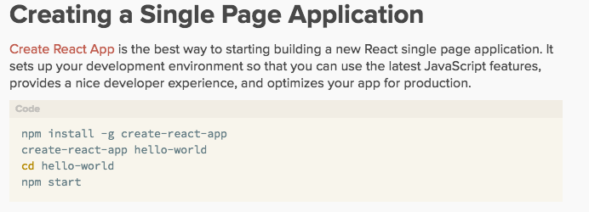

1. Under MAMP folder, command line
   * > git clone <https://github.com/kalarsu/react-project.git> , this will create a folder “react-project”
   * > cd react-project
   * > sudo npm install –g create-react-app , this will install react
   * > sudo npm create-react-app portfolio, this will create a project name portfolio and it’s folder
   * > npm cd portfolio, go into this folder
   * > npm start , to start the server
   * > git status , to check uncheck in files
   * > git add . to add all the untrack files
   * > git commit –am “install React and create first project” , to commit files
   * > git push , to push all the changes into repository
2. **Installing Babel for ES6 and JSX**

Ref: <https://babeljs.io/docs/setup/#installation>

1. >npm install –save-dev babel-cli
2. >npm install babel-preset-es2015 –save-dev